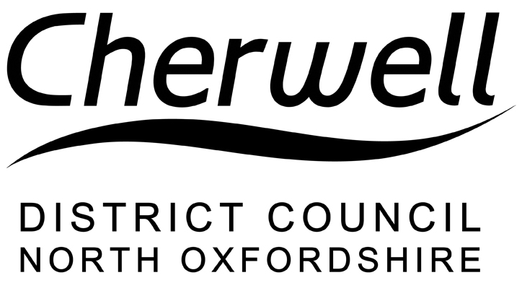
Deddington Neighbourhood Plan 2015 – 2031
Regulation 16 Consultation 8 November to 21 December 2018

Response Form

Deddington Parish Council has prepared a Neighbourhood Development Plan for Deddington Parish. The Plan proposes planning policies to be used in the determination of planning applications within the Neighbourhood Plan Area.

Cherwell District Council is undertaking public consultation on the draft (Submission) Plan. The draft Plan and supporting documents are available for public comment on-line at https://www.cherwell.gov.uk/planningpolicyconsultation

There are a number of ways to make representations (comments):

- Complete this form and email it to: PlanningPolicyConsultation@Cherwell-dc.gov.uk
- Print this form, fill it in and post it to: Planning Policy, Strategic Planning and Growth Strategy team, Cherwell District Council, Bodicote House, Bodicote, Banbury OX15 4AA.
- Email or post your representations without using this form to the above addresses

The deadline for the Council receiving comments is Friday 21 December 2018.

PLEASE NOTE THAT ANONYMOUS OR CONFIDENTIAL COMMENTS CANNOT BE ACCEPTED. YOUR NAME AND COMMENTS WILL BE PUBLISHED, BUT PERSONAL INFORMATION INCLUDING YOUR ADDRESS OR EMAIL ADDRESS AND TELEPHONE NUMBER WILL REMAIN CONFIDENTIAL.

All representations will be forwarded for consideration by the person appointed to carry out an examination of the Plan. Further information relating to the neighbourhood plan and examination process is available here https://www.gov.uk/guidance/neighbourhood-planning--2#the-independent-examination

How to use this form

Please complete Part A in full in order for your representations to be taken into account at the Neighbourhood Plan examination.

Please complete Part B identifying which part of the Plan your comment relates to. Please repeat Part B for subsequent comments relating to other parts of the Plan.

Feel free to include additional pages, making sure any additional pages are clearly labelled and attached.

If you have any questions about completing the form, please telephone 01295 227985.

PART A

 | Personal Details (if applicable) | Agent’s Details (if applicable)
Title

First Name

Last Name

Job Title (where relevant)

Organisation (where relevant)
Address

Postcode

Tel. No.

Email Address

PART B

Which part of the document do your comments relate to?

Section (and page number) |  | Policy/paragraph Reference:

Do you support, support with modification or oppose this section? (Please tick one answer)

Support | Support with modifications | Oppose

Please use the following space for your comments clearly stating the policy, paragraph or page number you are referring to and the reasons for your comments.

(Continue on separate sheet if necessary)

What improvements or modifications would you suggest? (Please provide reasons)

(Continue on separate sheet if necessary)

Would you like to be notified of the Council’s decision on whether to ‘make’ (adopt) the Neighbourhood Plan? (Please tick one box below)

Yes No

