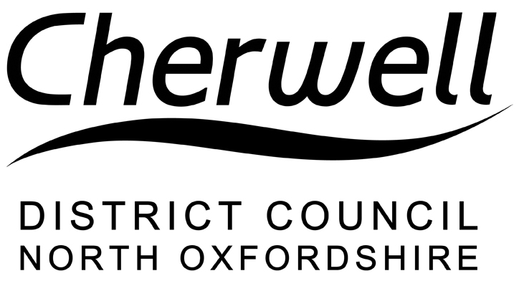
Neighbourhood Plan Proposal – Bloxham Parish
Consultation Response Form
Bloxham Parish Council has submitted its proposed Neighbourhood Plan to Cherwell District Council under Regulation 15 of the Neighbourhood Planning (General) Regulations 2012 (as amended). The proposed Neighbourhood Plan and related documents can be viewed online at www.cherwell.gov.uk/neighbourhoodplanning/ or as a hard copy at our Bodicote House offices, Banbury OX15 4AA 8.30am – 5.00pm and at Bloxham Mill Business Centre, Barford Road, Bloxham, Banbury, OX15 4FF from 8.30am – 3.45pm Monday – Friday.

Under Regulation 16, we are now required to publicise the Plan and supporting documents for a period of not less than 6 weeks and to invite represents before it is submitted for Examination. The consultation period will run between Friday 27 November 2015 and Friday, 22 January 2016. The statutory period has been extended by two weeks to allow for the holiday period. Representations received outside this period may not be accepted.

Representations can be made using this form and should be emailed to planning.policy@cherwell-dc.gov.uk or posted to Planning Policy, Cherwell District Council, Bodicote House, Bodicote, Banbury OX15 4AA.

Neighbourhood Plans are not examined in the same manner as plans produced by Local Authorities. Importantly, the Examiner is not to consider any matter other than those in the box below. As such, representations should only relate to such matters.
When examining the Neighbourhood Plan, the Examiner is required to consider the following:
A whether the draft neighbourhood development plan meets the basic conditions (see paragraphs E-H)
B whether the draft neighbourhood development plan complies with the provision made by or under sections 38A and 38B of the Planning and Compulsory Purchase Act 2004
C whether the area for any referendum should extend beyond the neighbourhood area to which the draft neighbourhood development plan relates
D whether the draft neighbourhood development plan is compatible with the European Convention on Human Rights

The draft neighbourhood development plan meets the basic conditions if:
E having regard to national policies and advice contained in guidance issued by the Secretary of State, it is appropriate to make the neighbourhood development plan
F the making of the neighbourhood development plan contributes to the achievement of sustainable development
G the making of the neighbourhood development plan is in general conformity with the strategic policies contained in the development plan for the area,
H the making of the neighbourhood development plan does not breach, and is otherwise compatible with, EU obligations.

Please include your contact details below

Name

Email/Postal Address

Please indicate if you wish to be notified about subsequent progress of the neighbourhood plan, including when the District Council makes a decision about ‘making’ the plan (under Regulation 19), by marking ‘X’ in the box below:

Using information contained in the box on Page 1, please indicate which paragraph your representation relates to by marking an ‘X’ in the appropriate box(es) below:

A B C D

If your representation relates to paragraph A, please identify which of the following your representation relates to by marking ‘X’ in the appropriate box(es)

E F G H

Please use the following space to write your representation, clearly stating the policy, paragraph or page number you are commenting on. Continue on further sheets, as necessary.

(continue on a separate sheet if necessary)

Do you have any comments to make on the supporting documents?

(continue on a separate sheet if necessary)

